NTE (Not to Exceed) is a value that can be required or voluntary when entering an order.

It is the maximum doses a patient should receive in 24 hours.

A statement will appear under the med in the MAR with the max number listed.
The # will decrement with each med admin until it hits zero.
At that point, all admin time blocks still left in the 24 hour time frame will be removed.

Example: Arbour-Fuller chose to require it for all PRN orders.

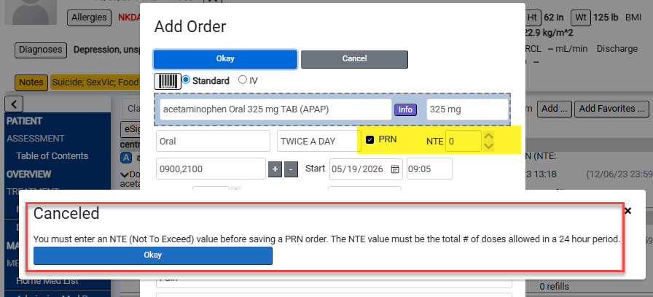

I hit OK & entered 6 (see bottom of next image).
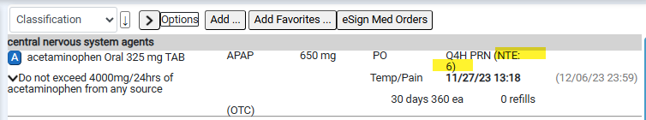

Note: Facilities can have NTE set facility wide to an actual date/time or time of the prescription.

